**OSI Model 7 Layers Functions**

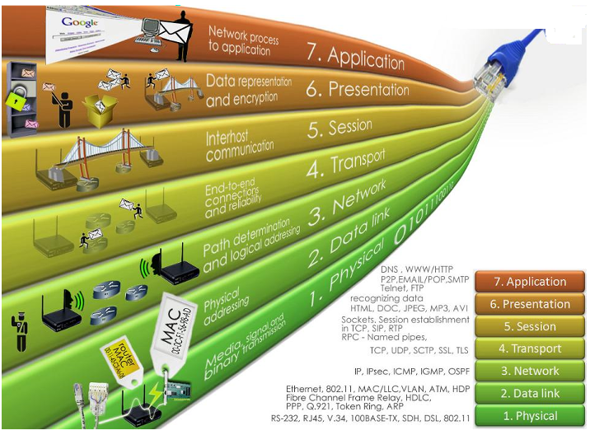

**OSI Model** -The Open Systems Interconnection model (OSI model) is a conceptual model that characterizes and standardizes the communication functions of a telecommunication or computing system without regard to their underlying internal structure and technology.

Its goal is the interoperability of diverse communication systems with standard protocols. The model partitions a communication system into abstraction layers. The original version of the model defined seven layers.

A layer serves the layer above it and is served by the layer below it.

For example, a layer that provides error-free communications across a network provides the path needed by applications above it, while it calls the next lower layer to send and receive packets that comprise the contents of that path.

Two instances at the same layer are visualized as connected by a horizontal connection in that layer.

**Layers Functions**

The OSI model (Open System Interconnection) model defines a computer networking framework to implement protocols in seven layers. A protocol in the networking terms is a kind of negotiation and rule in between two networking entities.

**Layers of OSI model:**

**Physical layer**

The Physical layer is also called as the Layer 1. Here are the basic functionalities of the Physical layer:

* Hardware layer of the OSI layer
* Responsible for electrical signals, light signal, radio signals etc.
* Transforming bits into signals
* Provides synchronization of bits by a clock.
* Physical layer manages the way a device connects to network media.
* It defines the transmission rate.
* It defines the way in which the devices are connected to the medium.
* It provides physical topologies
* It can use different techniques of multiplexing.
* Devices like repeater, hub, cables, ethernet work on this layer
* Protocols like RS232, ATM, FDDI, Ethernet work on this layer

**Data Link layer**

The data link layer is also called as the Layer 2 of the OSI model. Here are the basic functionalities of the data link layer:

* It is responsible for node-to-node delivery of data.
* It receives the data from network layer and creates FRAMES , add physical address to these frames & pass them to physical layer
* It consist of 2 layers:
  + **Logical Link Layer (LLC)**:Defines the methods and provides addressing information for communication between network devices.
  + **Medium Access Control (MAC)**:establishes and maintains links between communicating devices. It controls how a computer on the network gains access to the data and permission to transmit it. It controls frame synchronization, flow control and error checking.
* **Framing** :DLL divides the bits received from N/W layer into frames. (Frame contains all the addressing information necessary to travel from S to D).
* **Physical addressing**: After creating frames, DLL adds physical address of sender/receiver (MAC address) in the header of each frame.
* **Flow Control:** DLL prevents the fast sender from drowning the slow receiver.
* **Error Control:** It provides the mechanism of error control in which it detects & retransmits damaged or lost frames.
* **Access Control:** When single comm. Channel is shared by multiple devices, MAC layer of DLL provides help to determine which device has control over the channel
* Responsible for encoding and decoding of the electrical signals into bits.
* Manages data errors from the physical layer
* Converts electrical signals into frames
* MAC address is a part of the layer 2.
* Devices like Switch work at this layer

**Network Layer**

The Network layer is also called as the layer 3 of the OSI model. Here are the basic functionalities of the network layer:

* It is responsible for the source to destination delivery of a packet across multiple networks.
* If two systems are attached to different networks with devices like routers, then N/W layer is used.
* Thus DLL overseas the delivery of the packet between the two systems on same network and the network layer ensures that the packet gets its point of origin to its final destination.
* **Internetworking**: It provides Internetworking.
* **Logical Addressing:** When packet is sent outside the network, N/W layer adds Logical (network) address of the sender & receiver to each packet.
* Network addresses are assigned to local devices by n/w administrator and assigned dynamically by special server called DHCP (Dynamic Host Configuration Protocol).
* **Routing:**When independent n/w are connected to create internetwork several routes are available to send the data from source to destination. These networks are interconnected by routers & gateways that route the packet to final destination. Routes the data packet to destination.
* Creates logical paths between two hosts across the world wide web called as virtual circuits
* Routing and forwarding of the data packets.
* Internetworking, error handling, congestion control and packet sequencing work at this layer
* Router works at layer three.
* Different network protocols like TCP/ IP, IPX, AppleTalk work at this layer

**Transport layer**

The Transport  layer is also called as the layer 4 of the OSI model. Here are the basic functionalities of the Transport layer:

* It is responsible for process-to-process delivery of the entire message.
* TL looks after the delivery of entire message considering all its packets & make sure that all packets are in order. On the other hand n/w layer treated each packet independently.
* At the receiver side, TL provides services to application layer & takes services form n/w layer.
* At the source side, TL receives message from upper layer into packets and reassembles these packets again into message at the destination.
* Transport Layer provides two types of services:
  + **Connection Oriented Transmission:** In this type of transmission the receiving devices sends an acknowledge back to the source after a packet or group of packet is received. It is slower transmission method.
  + **Connectionless Transmission:** In this type of transmission the receiving devices does not sends an acknowledge back to the source. It is faster transmission method.
* Segmentation of message into packet & reassembly of packets into message.
* **Port addressing:** Computers run several processes. TL header include a port address with each process.
* **Flow Control:** Flow control facility prevents the source form sending data packets faster than the destination can handle.
* **Error control:** TL ensures that the entire message arrives at the receiving TL without error.

**Session layer**

The Session  layer is also called as the layer 5 of the OSI model. Here are the basic functionalities of the Session layer:

* Segmentation of message into packet & reassembly of packets into message.
* **Port addressing:** Computers run several processes. TL header include a port address with each process.
* **Flow Control:** Flow control facility prevents the source form sending data packets faster than the destination can handle.
* **Error control:** TL ensures that the entire message arrives at the receiving TL without error. Establishing, Maintaining and ending a session: When sending device first contact with receiving device, it sends syn(synchronization) packet to establish a connection & determines the order in which information will be sent. Receiver sends ack (acknowledgement). So the session can be set & end.
* **Dialog Control:** This function determines that which device will communicate first and the amount of data that will be sent.
* **Dialog separation:** Process of adding checkpoints & markers to the stream of data is called dialog separation.
* Protocols like NFS, NetBios names, RPC, SQL work at this layer.

**Presentation layer:**

The Presentation layer is also called as the layer 6 of the OSI model. Here are the basic functionalities of the presentation layer:

* It is concerned with the syntax & semantics of the information exchanged between the two devices.
* It was designed for data encryption, decryption and compression.
* **Data Presentation or Translation**: Because different computers use different encoding systems. It ensures that the data being sent is in the format that the recipient can process.
* **Data Encryption:** PL provides this facility by which hides the information from everyone except the person who originally sent the information & the intended recipient. When encrypted data arrives at destination, PL decrypts the message.
* **Data Compression:** PL shrinks large amount of data into smaller pieces i.e. it reduces the size of data.
* Layer 6 Presentation examples include encryption, ASCII, EBCDIC, TIFF, GIF, PICT, JPEG, MPEG, MIDI.

**Application Layer:**

The Application layer is also called as the layer 7 of the OSI model. Here are the basic functionalities of the Application layer:

* It enables the user to access the network.
* It provides user interface & supports for services such as e-mail, file transfer, access to the world wide web.
* So it provides services to different user applications.
* **Mail Services:** This application provides various e-mail services.
* **File transfer & Access:** It allows users to access files in a remote host, to retrieve files from remote computer for use etc.
* **Remote log-in:** A user can log into a remote computer and access the resources of that computer.
* **Accessing the World Wide Web:** Most common application today is the access of the World Wide Web.
* Protocols like Telnet, FTP, HTTP work on this layer.